Southwest Airlines Case Analysis
Student name
Intuitional affiliations
Course
Date

. Question 1
What grade would you give the Southwest top management team for the job it has done in crafting the company’s strategy?
The system of the organization is at an upright state since it guaranteeing that it is at a position of being a nominal effort benefactor, and it isn't providing relinquishes of a slight style of exchange flights. This can be the reason that makes me love the southwest procedure increasingly as a result of their stay on the strategy within the entire process, as a result of their improved process, I will give Southwest grade A.

What are the key policies, procedures, operating practices, and core values underlying Southwest's efforts to implement and execute its low-cost/no frills strategy? Is Southwest's strategy sustainable?
The Southwest Airline's key policies are as follows; the organization guarantees visit flights, low fares, maintaining the low expenses, and guaranteeing that there's a fast extension of its corporate into new urban communities. The organization has the favor of making contracts that area of positive perspective since it'll get its fuel with ease (Brooks, 2010, 55). This has thus prompted the organization in remarkably beating her rivals since it is creating big advantages that are unit persuasive to maintain the company’s stability. The operating practices of the company are more productive, that is, giving more thoughtfulness relating to customers and lower prices. The fundamental beliefs of the organization are that it guarantees that it keeps up its products, keeping the procedure smooth, dominant expenses, obtaining the highest position customer service ratings, and utilizing the electronic ticketing. The organization has, in addition, existent its ease strategy by guaranteeing there's a high level of teamwork, and therefore, the harmonization of the employees is a reason behind the successful implementation through the people that are behind the productive execution.
What is it that you most like or dislike about the strategy?
I would give Southwest Airlines alike since it ensures that the strategy is maintained throughout the whole process.

Question 2
. Do you believe that Southwest's management has done an excellent job implementing and executing the company's strategy that was created?

I agree that the organization has had proper management because it has been in a position of executing out the policy by guaranteeing that it is giving low expenses, avoiding giving penalties on delayed flights.
Which of Southwest’s strategy execution approaches and operating practices do you believe have been most crucial in accounting for the success that Southwest has enjoyed?
Southwest Airlines is the major airline in the United States of America. The reason that is behind the accomplishment of its strategy is that the capable administration. The process of implementing the policies and management is at another high level (Carter, Rogers, and Simkins, 2004, p. 107). The execution techniques and viable practices that are more important are low-cost, and management has been discussed below.
The low-cost strategy.
The management of the organization executed the same strategy that guarantees that the cost of the tickets is minimized and consequently ensuring that flights obtain will be affordable to the customers. There are significant efforts that are created for the present strategy. The organization has been utilizing a specific style of flying aircraft with the goal that it will minimize the value and time of the operations. Southwest Airlines is the first organization to come up with the ticketless framework that's cost accounting $1 as an alternative choice of $4. The organization likewise executes plans that are directed to reducing the additional charges, saving time on travelers, and rising technology. The organization's individualism in decreasing the operating expenses and giving the most straightforward possible price to the customers is behind the accomplishment of strategies. The organization, in addition, guarantees that it was upholding its service quality.
Management
The leaders of Southwest are capable all in adding that the CEO, Herb Kelleher. Kelleher guarantees that the tasks of the organization are successively commendable by ensuring that teamwork is improved. Kelleher does this by operating licitly with employees instead of working from home.
The administration of the organization strives to ensure that the employees are happy with the organization. As an example, the employees suggested that the organization ought not to place logos on refuse packs, and therefore, the recommendation was implemented saving $250000 per annum. The organization contains a substantial certainty of giving the employees their first priority, then followed by the customers. The priority that the employees are granted shows that the management is specific that the employees would be passionate about their work and hence the thesis of the company; Keep workers contented, and they will have a customer contended.
The management in Southwest ensured that the employed staff for defiance and qualified intended skills. This can be the motivation behind why the employees possessed a hardworking motive, thus the desire for customer service. The staff that manages recruitment of employees in Southwest Airline organization did a careful investigation of every activity category with the goal that they determine specific job exhibitions knowledge that the activity holders needed so that they can utilize the foretold attributes This was a positive thought because the administration prompted obtaining proficient workers that are determined to do their work with passion. This has thus prompted the organization to additional acceptive customers and hence high profits
Are there any policies, procedures, and operating approaches at Southwest that you disapprove of or that are not working well?
I think that there aren't any completely different approaches in Southwest Airlines that I denounce since I feel that it is operating at its high level.

Question 3
What are the key elements of Southwest’s culture?
The significant elements of Southwest Airlines' culture are; the climate is full of fun associated with tantalizing work and is being improved over participating exhibitions in their employments, constant deceives and quips, High pay, as well as allurements and regular organization, supported parties and festivals.
Southwest Airlines see their culture to be jointly hence can operate on anything that they will operate on anything one they have set it on their minds. Kelleher has modified the Airline organization into being a big carrier, and it is absolutely (Diermeier and Heinze, 2007, p. 98). Kelleher may, as a rule, check the companies in order to ensure that they get no matter what was needed, therefore on complete their activity well. He treated the workers in a very quick manner like they were his family.
Do you think that the corporate culture is influential? Why or why not?
I think the company culture is robust since it guarantees the workers unity. Through this, the workers will add a perfect domain on these lines; hence, high profits are gained.
Do you think that Gary Kelly will have problems sustaining the culture now that Herb Kelleher, the company’s long-time spiritual leader, has departed?
I think he will not face challenges in supporting Southwest's Airline's theory since he can pursue the precise strides of Kelleher. Herb Kelleher is the one who sustained operations and policies of the organization, making it exceed the organization's rivals. Kelleher believes in Kelly since he will accomplish great achievements making the creating the airline organization to ascend to extraordinary heights. Kelly is keen on staying with them to be the simplest among others in the world, and this can be likewise one thing useful for employers and customers, and it'll be tired done in an appropriate way. Kelleher's strategy was that he satisfied the management team to go looking, and henceforward Kelly should have a plan that will ensure the policies are implemented. Kelly can likewise guarantee that the organization's quality balance sheets reports are preserved to pointers and keeping minimal debts and high profits. For Kelly to maintain a strategic distance from future problems, he should guarantee that the organization is frequently running at low prices, high defiance, and solely treatment of employees being equal and, therefore, the organization's customers. Since the organization was found on a trustworthy institution of conviction and family, it'll be challenging to lose the organization's fundamental beliefs and customers.

Question 4
. What is the "triple bottom line"? How does this relate to ethics and corporate social responsibility?
Triple bottom line concern could be a hypothesis that goes additional to grow the previous accounting layout, so there may be two added performing zones. These territories are social and environmental impacts of the connected organization. As a rule, the triple bottom line's primary concern is said with the people, planet, and profit because the name proposes.
People
With regards to people, the employees are thought of, work that's given throughout partnership work. Another methodology for seeing, however, the expression people are used is through taking a goose at what quantity will the organization is useful to the community (Humphrey, 2013, p. 200). The organization guarantees that the wages are paid and guaranteeing particular needs are maintained for the employee operating conditions.
Planet
With regards to planet, the ideology is that if the organizations do harm to the planet got to acknowledge the expense. The "planet" under triple bottom line concern shows that any organization got to limit its ecological impression the maximum amount as potential. This could be potential by guaranteeing that they need diminished waste, utilizing property power supply, and utilizing alternative characteristic assets.

Profit
Under the triple bottom line concern, every business got to guarantee that it is financially profitable. This got to be viewed as the main objective of the company.
Corporate social responsibility is a practice that guarantees the activities of the organization are helpful to the community. The connection that exists between triple bottom line and ethics and corporate social responsibility is that the interests of triple bottom line are guaranteeing that the organization goes concerning as operator of the setting, to the society and also the economy in general whereas company social responsibility characterizes the fuse of social and also the environmental problems consequently deciding on appropriate selections, shaping objectives and guaranteeing that the tasks of the business are running commendably. With regard to morals, it guarantees that the interests of the staff, clients, partners, and also the network once all is alleged in done are met because the triple bottom line guarantees that the planet, civilization, and also the economy as a rule.
.
Do you view Southwest as socially responsible?
I see Southwest be socially responsible. This is often on the grounds that the organization has gone to a further mile in presumptuous company liability to a different level. This is often on the grounds that the organization is presently partaking in philanthropic gift-giving, volunteerism, and also the biological creativities. The organization is committed to guaranteeing the preservation of the planet. The organization is to boot endeavoring laborious to ensure that limit the impact of the environmental modification within the general public and maintaining their stay on the triple bottom line of planet, people and profit ("Leadership Analysis: Southwest Airlines - Herb Kelleher, CEO," 2018, p. 158). The Southwest Airlines organization fortifies the devotion to the protection and qualifying the environmental effects, and this is often a reality that shows, however, the organization is targeted is committed to the environmental.
Explain. In your opinion, should they do anything differently in this regard and why/why not?
I figure out that the organization got to go additional to guarantee that it accomplishes the company's social corporate responsibility. This is often on the grounds that within the in progress universe of business, there's a high challenge so on exceed the contenders, the Southwest organization got to be in a very state of affairs to administer outstanding services and product and what is more coping with its partners, customers, environment and also the employees.

Question 5
Complete a comprehensive SWOT analysis (include specific financial ratios and information also) of Southwest as of the case date.
Strengths
The strengths for Southwest Airline and also the core ability is the cost administration. This organization is that the biggest ease association that's operating the United States of America, and it offers varied styles of travelers, and this can be the best association since it can convey in far more than 3,000 flights daily. The opposite vast quality of the organization is that the complete image that has prompted the development in important arrangement administrations for a significant stretch of your time that's over forty years. One thing else that's staying with the within the condition of alternative targeted aircraft is that the token effort methodology. The incomes that are raised up from operations of the organization have indicated a growing pattern, and therefore, it makes the organization ensure relentless development system and creating its state of affairs within the business firm. Other than the event of its business activities, it's had the choice to own a tasty variety of accomplishments in numerous associated service industries. The employees of Southwest Airlines do their responsibility obligations with duty and devotion.
Weaknesses
Notwithstanding the organization is the first elevated carrier within the US, despite everything, it still operates on the local market. The organization has been performing throughout the previous forty years, and it got to have this time opened its operations into the global skin market. This disadvantage has driven the organization to make low profits. The various difficulty that the organization is experiencing right presently is that it depends upon merely one plane manufacturer. The organization offers single category passenger travel that could be a constraint to creating additional deal incomes on the grounds that the customers do not find their specified category, and henceforward, they're compelled to alter to completely different carriers. The last disadvantage is that it lacks the morning flights, and hence, the market is limited.
Opportunities
The organization has completely different opportunities that may cause it to turn into the worldwide markets. The organization has to ensure morning flights with the goal that it will attract additional customers. The second opportunity that the organization has will isolate the passenger travel into official and also the economic categories, whereas maintaining a low price. They should also improve customer service so that they can be more competitive. The Airline organization will likewise utilize a high amount in finishing its research and also the improvement with the goal that it could have the choice to administer more advanced technology and increasing customer care. Southwest Airlines will build employable showcasing and business enterprise energies visible to attach its low-value prices and give discounts.
Threats
The threat that's facing Southwest Airlines is that it’s not in a very stable position of affairs to make sure its favourite place in the competitive business world. This is because other companies are adopting the same strategy as the one for Southwest Airlines of low- price strategy. This so prompts a healthy competition to Southwest Airlines in its region of doing its operations. Other threats are increased fuel prices and terrorism attacks.

. What strategic issues and problems do Gary Kelly, and Southwest executives need to address as of mid-2016?
So far, the organization is activities show that it's performing massively well. The methodologies and problems that Garry and also the executive ought to address are as per the following; The Southwest organization has to take a look at the competition business with the goal that it will maintain its high competition in the future. The other issue that Gary and the management have to address is how to increase its operations into large airports and to take new routes to increase the number of customers.

Question 6
Analyze the most recent financial information.
The following table and chart show the financial analysis of Southwest Airlines in recent times. The table contains the real and also the estimated millions, which will be acknowledged by the company. The report has been calculated for the actual years 2016,2017,2018, and also the estimated figures within the year 2019, 2020, and even the year 2021.

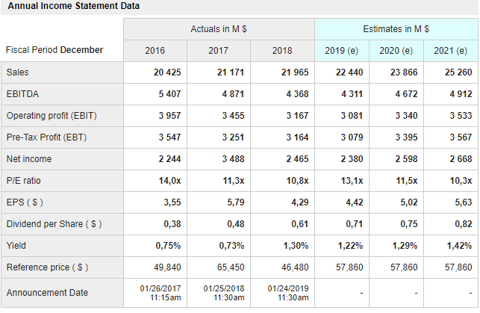
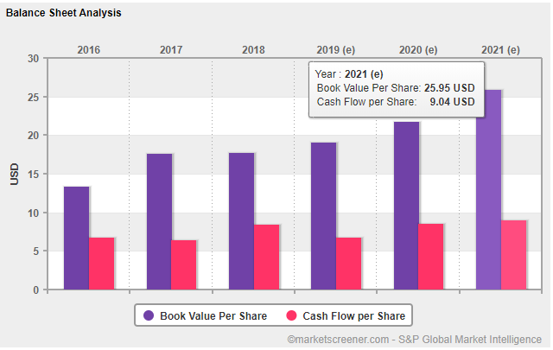

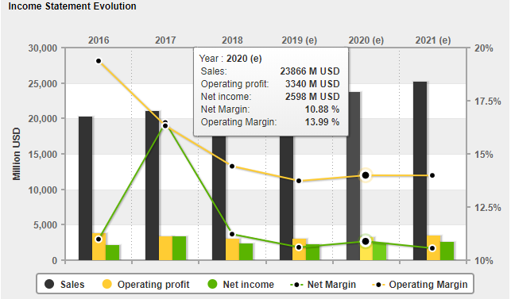

Which SWOT components have changed?
The organization has the potential of developing on the off probability that it will utilize new procedures in controlling, business extension, and guaranteeing that new associations are formed. New organizations can be accomplished by forming an alliance with non-aircraft companies, and this will open their operations to the global market.

what recommendations would you make to Southwest executives as the company moves forward?
My recommendation is that Gary should consider increasing the number of flights into new routes so that there could be increased profits and make sure that flights are reduced in the regions where passengers are less. The last recommendation is that the organization should ensure that they form partnerships with other companies.

References
Brooks, R. E. (2010). A Life-Cycle View of Enterprise Risk Management: The Case of Southwest Airlines Jet Fuel Hedging. SSRN Electronic Journal.
Carter, D. A., Rogers, D. A., & Simkins, B. J. (2004). Fuel Hedging in the Airline Industry: The Case of Southwest Airlines. SSRN Electronic Journal.
Diermeier, D., & Heinze, J. (2007). Southwest Airlines Flight 1248 (B).
Humphrey, R. (2013). James Parker, Southwest Airlines: Not the Best People but the Right People.
Leadership Analysis: Southwest Airlines - Herb Kelleher, CEO. (2018). Journal of Leadership, Accountability, and Ethics, 15(1).
https://www.youtube.com/watch?v=FI6dT0zMRB4.
https://www.youtube.com/watch?v=j0ibULnU8_s

